Cedar Grove Panthers socks and sandals sale brought to you by the North End FSA

Slides are unisex plain black and gold
(no writing or paw printed on them).
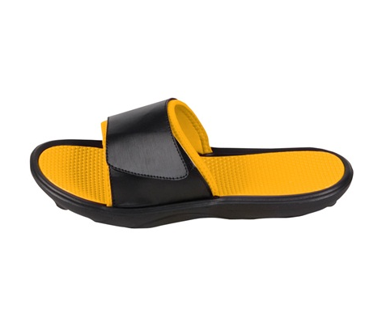
Solid socks will have the Cedar Grove Panther PAW and the word ‘Panthers’ down the SIDE.
Gold sock will have black print and Black sock will have gold print.
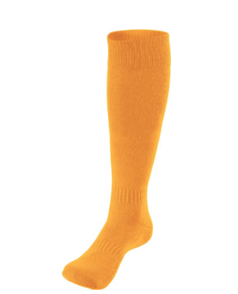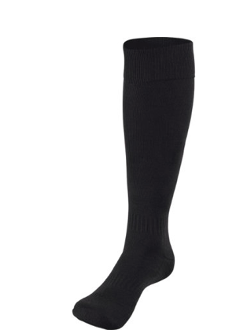

Black and Gold socks will have the
Cedar Grove Panther PAW and the word ‘Panthers’ down the BACK in GOLD.
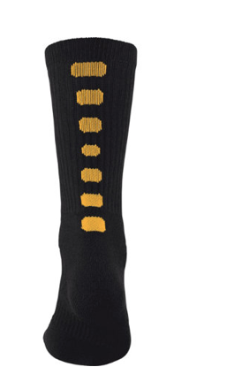

Please fill out the attached order form and return to the NE FSA.

Due by 9/30/14
Contact Sue Kolakowski with any questions: suenj22@yahoo.com

Sandals | Size | Quantity | Price | Total
 | XS |  | $23
 | S |  | $23
 | M |  | $23
 | L |  | $23
 | XL |  | $23
Sock and Sandal Order Form
Solid Gold Socks | Size | Quantity | Price | Total
 | Youth 1-4 |  | $13
 | Ladies 4-5 |  | $13
 | Ladies 5-10 |  | $13
 | Mens 4-7 |  | $13
 | Mens 8-13 |  | $13
Solid BLACK Socks | Size | Quantity | Price | Total
 | Youth 1-4 |  | $13
 | Ladies 4-5 |  | $13
 | Ladies 5-10 |  | $13
 | Mens 4-7 |  | $13
 | Mens 8-13 |  | $13
Black & Gold Socks | Size | Quantity | Price | Total
 | Youth 1-4 |  | $13
 | Ladies 4-5 |  | $13
 | Ladies 5-10 |  | $13
 | Mens 4-7 |  | $13
 | Mens 8-13 |  | $13

TOTAL AMOUNT DUE: _____________________

Please make checks payable to North End FSA – due by 9/30/14.

Name: ________________________________________________________________________

Email: ________________________________________________________________________

